Help Sheet
Gas Laws

Chapter 10

Units …

Pressure Volume Temperature
1 atm 1 liter K = ºC + 273
76 cm Hg 1000 ml (Temperature – an absolute scale)
760 mm Hg 1000 cc
760 torr 1000 cm³
101.325 kPa STP = 1-atm and 0ºC
14.7 psi (Standard Pressure and Temperature)

Boyles Law …

P x V = Constant P P

V 1/V

Charles’ and Gay-Lussaic’s Law …

V/T = Constant V

T

Combined Gas Law …
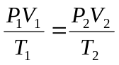 PV/T = Constant

Ideal Gas Law …
PV = nRT R = .0821 liter.atm/mole.K
HINT: Convert P to atm, V to Liters

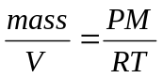 Density …

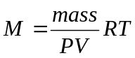 Molar Mass …

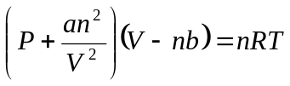Deviation …
a = correction for inter-molecular forces b = correction for volume of atoms

Stoichiometry …

Question: 36.0-gm of methane (CH₄) burn in air. Determine the volume of gas produced at 25ºC.
Assume the products are gases collected at 1-atm.
Answer: 165 liters
Solution:
CH₄(g) + 2O₂(g) → CO₂(g) + 2H₂O(g)

(36-gm CH₄) / (16-gm/mole) = 2.25-mol CH₄(g)

Therefore; 2.25-mol of CO₂ and 4.50-mol H₂0 Total moles of gas = 6.75-mol

PV = nRT V = nRT/P V = (6.75-mol)(.0821-liters.atm/mol.K)(298-K)/(1-atm)

Dalton’s Law of Partial Pressures … ‘the total pressure of a mixture of gases is the sum of the pressures that each gas would exert if it were present alone.’

P_{T} = P₁ + P₂ + P₃ + …P_{n}

Mole Fraction …
P_{a} = X_{a}P_{T} P_{b} = XbP_{T} P_{c} = X_{c}P_{T}

X_{a} = (mol a)/(total mols)

Kinetic Theory …
Assumptions: 1. Gases may be considered to be point masses. No volume, just mass.
- Gas molecules move in random motion with ‘elastic’ collisions.
- Gas molecules do not have any inter-molecular forces.
- Two gases at the same temperature have the same kinetic energy.

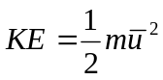
KE (Kinetic Energy) is proportional to T (Temperature)

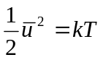

Molecular Speed of a Gas …
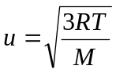

R = 8.314 J/K.mol
M = molecular mass in kg/mol

Question: What is the RMS (root mean square) speed of O₂ atoms in air? Assume T = 25ºC
Answer: u_{avg} = 481 m/s or 1735 km/hr or 1084 mi/hr (MACH 3 Plus)
Solution:
